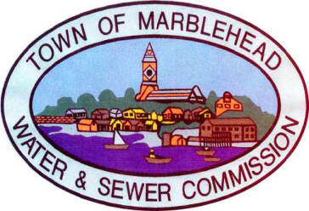

September 14, 2022

Due to a water line break, you may experience low water pressure, discolored water or disruption of water service. Residences that received a message from the Water Department may have temporary water service disruptions.

The Water Department is working to repair this break and will restore full water service as soon as possible.

If you experience discolored water, please flush your water system by running a faucet in your sink (cold water only) until the water clears. Refrain from running hot water or doing laundry until the water runs clear.

Contact the Water Department at
781 631-0102 if you have any questions

